STUDENT RECORD MANAGEMENT SYSTEM

Submitted by:
Tejaswini B H (20251CAI0329)
Parvathy Ajith (20251CAI0363)
Course: B.Tech CS (AIML)
College:Presidency University Ittagallpura, Karnataka
Guide: Ms Rajitha Reddy
Date: 8/4/2026

Abstract
The Student Record Management System is a simple yet effective application developed using the C programming language. The main objective of this system is to store, organize, and manage student information efficiently.
The system allows users to perform various operations such as adding new student records, displaying existing records, searching for specific students, updating student details, and deleting records when necessary. All the data is stored using file handling techniques, which ensures permanent storage even after the program is closed.
This project helps in reducing manual paperwork, minimizing errors, and improving the efficiency of maintaining student data. It also demonstrates fundamental concepts of C programming such as structures, file handling, and modular programming.

1. Introduction
In educational institutions, maintaining student records is an essential task. Traditionally, this process is carried out manually using registers or files, which can be time-consuming, inefficient, and prone to human errors.
With the advancement of technology, computerized systems have replaced manual methods to improve accuracy and efficiency. The Student Record Management System is designed to overcome the limitations of manual record-keeping.
This project is implemented using the C programming language and uses file handling to store data permanently. It provides an easy-to-use interface where users can manage student details systematically. The system ensures quick access, modification, and deletion of records, making it highly useful for small-scale applications.

2. Objectives
The main objectives of this project are:
- To develop a simple and user-friendly system for managing student records
- To understand and implement file handling concepts in C
- To perform CRUD operations (Create, Read, Update, Delete) efficiently
- To reduce manual effort and improve data accuracy
- To gain practical knowledge of structures and functions in C

3. System Requirements

Hardware Requirements:
- Computer or Laptop
- Minimum 4GB RAM (recommended)

Software Requirements:
- C Compiler (Code::Blocks / Turbo C / GCC)
- Operating System (Windows / Linux / MacOS)

4. System Design
The system follows a menu-driven design, which allows users to interact with the program through a set of options.

Modules of the System:
- Add Student: Enter new student details
- Display Records: View all stored records
- Search Student: Find a student using roll number
- Update Student: Modify existing student details
- Delete Student: Remove a student record
Each module is implemented as a separate function for better modularity and readability.

5. Data Structure Used
struct student {
int roll;
char name[50];
float marks;
char grade;
};
The structure is used to store student details in a grouped format. It makes the program organized and easy to manage multiple data fields.

6. Methodology
The system is developed using a step-by-step approach. First, the structure is defined to store student data. Then, functions are created for each operation such as adding, displaying, searching, updating, and deleting records.
File handling is used to store data in a file named students.txt. The program reads from and writes to this file using standard file handling functions like fopen(), fwrite(), fread(), and fclose().
When the user selects an option from the menu, the corresponding function is executed. This approach ensures smooth execution and better user interaction.

7. Algorithm
- Start the program
- Display the menu options
- Accept user choice
- Perform the selected operation:
- Add / Display / Search / Update / Delete
- Repeat the process until the user chooses to exit
- Stop the program

8. Working of the System
- Add Student:
The user enters student details such as roll number, name, marks, and grade. The data is stored in the file.
- Display Records:
All student records stored in the file are displayed on the screen in a readable format.
- Search Student:
The user enters a roll number, and the system searches the file to find and display the matching record.
- Update Student:
The system allows modification of an existing record by searching for the roll number and updating the details.
- Delete Student:
The selected record is removed by copying all other records to a temporary file and deleting the original entry.

9. Output Screens
- Menu screen
- Add student screen
- Display records screen

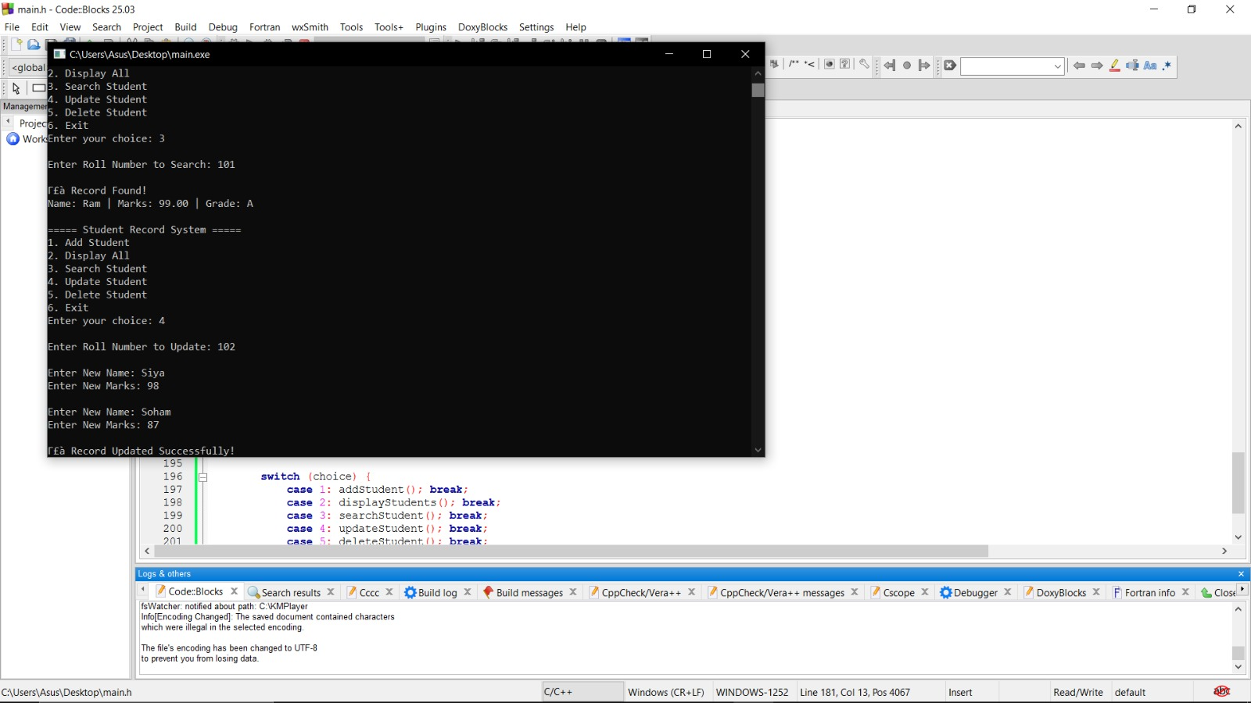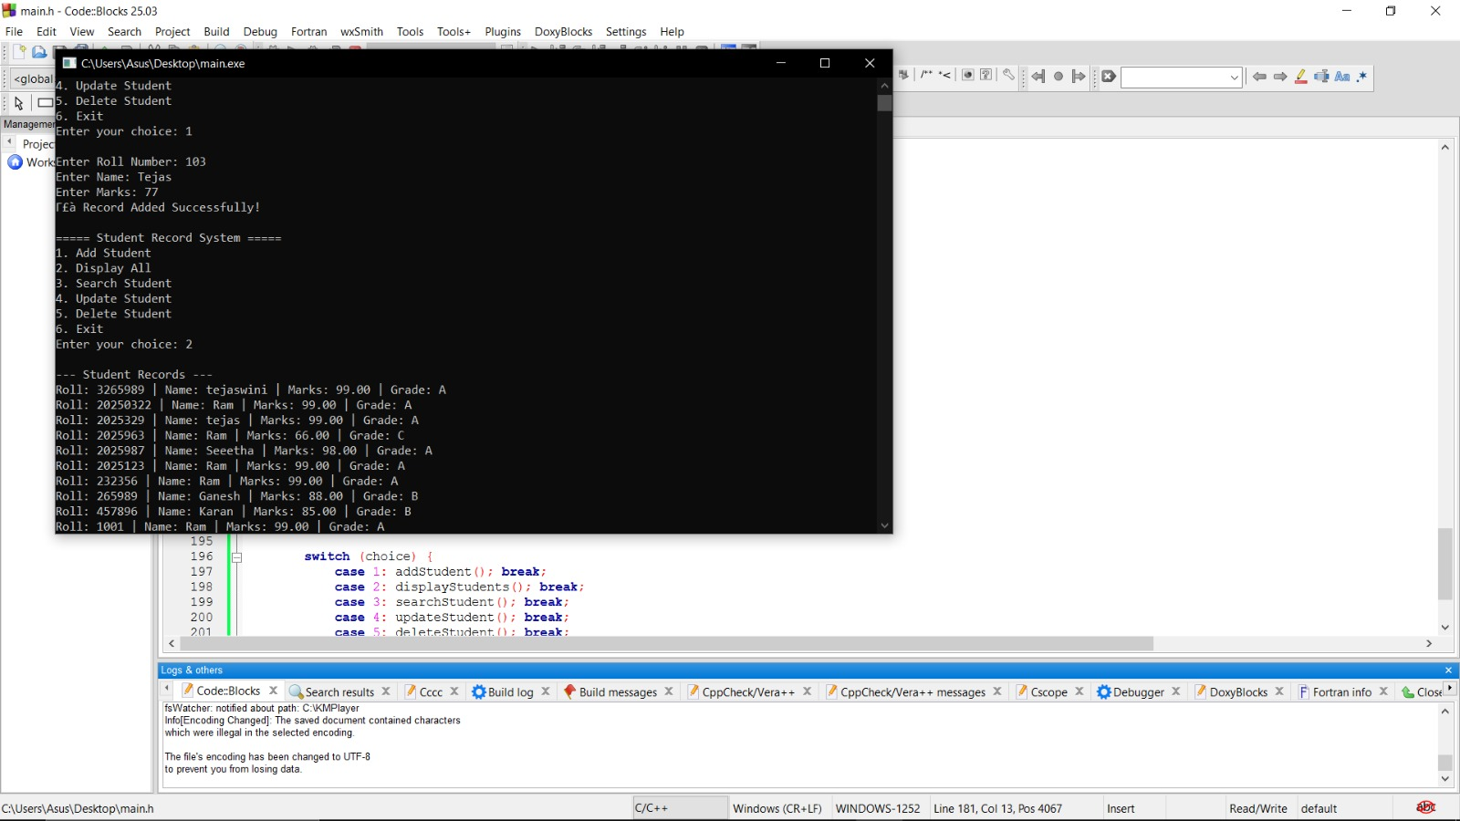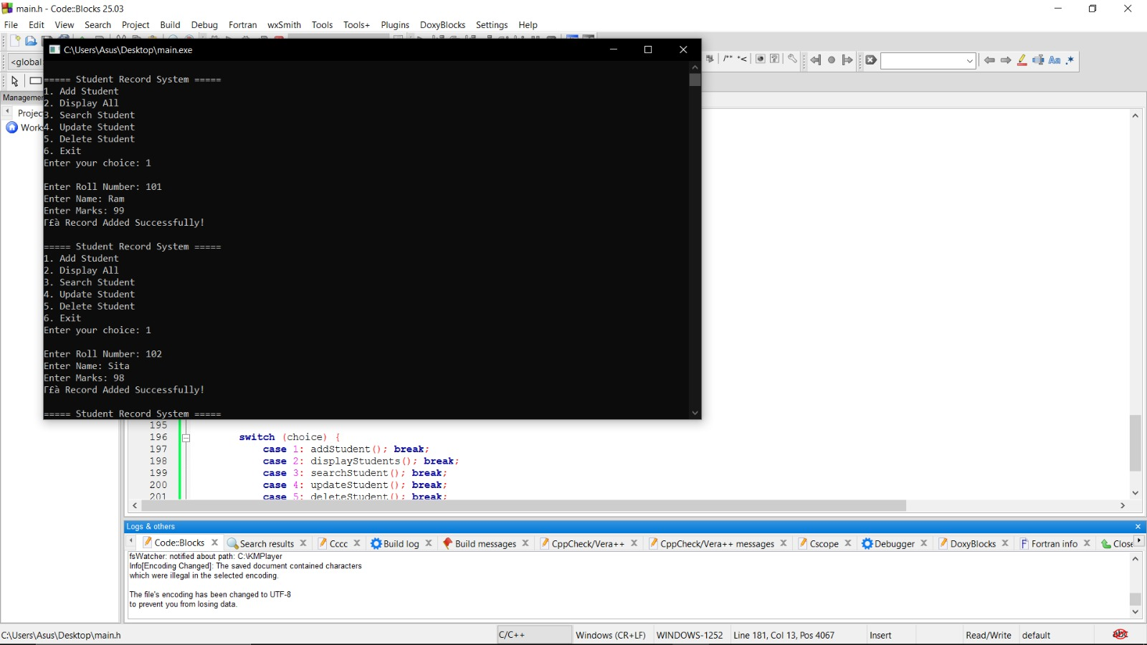

10. Advantages
- Simple and easy to use
- Reduces manual work and paperwork
- Provides quick access to data
- Minimizes human errors
- Ensures permanent data storage using files
- Helps in understanding core programming concepts

11. Limitations
- No security or authentication system
- Works only on a local system (not online)
- Limited to basic functionalities
- Cannot handle very large databases efficiently

12. Future Enhancements
- Add password protection for security
- Convert into a GUI-based application
- Store data using databases like MySQL
- Add features like sorting and report generation
- Make it accessible online

13. Conclusion
The Student Record Management System is a basic yet powerful application developed using C programming. It successfully demonstrates the use of structures, file handling, and modular programming.
The system provides an efficient way to manage student data and reduces the complexity of manual record-keeping. This project also helps in building a strong foundation in programming concepts, which can be extended to more advanced applications in the future.

